Comparison of Pylint and ChatGPT code review
Code snippets:
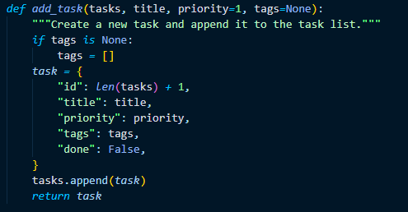
Pic 1: First code snippet
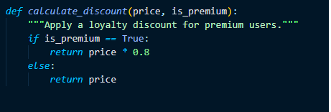
Pic 2: Second code snippet

Issue | What Pylint found | What AI found | Difference
Mutable default tags=[] in add_task() | Flagged dangerous mutable default (W0102). | Explained how the list can be shared between calls and suggested using None. | Pylint identified the issue but did not explain its practical consequence as fully as AI.
Boolean comparison in calculate_discount() | Flagged comparison with True (C0121). | Confirmed the comparison is unnecessary and suggested simpler logic. | No major issue missed by either tool for this concern.
Unnecessary else in calculate_discount() | Flagged else after return (R1705). | Recommended simplifying the function structure. | Both tools detected the same readability issue.
Price validation in calculate_discount() | Did not flag missing validation. | Raised a possible design concern about negative or non-numeric prices. | AI provided a consideration that Pylint did not report.

Reflection
Yes. The AI reviewer surfaced a potential design concern that Pylint did not report. For example when reviewing the calculate_discount() function, AI raised the question of whether the function should validate the price to prevent negative or non-numeric values. This concern depends on the system requirements and was not identified by Pylint in its report.

